Trip Report July 2019
Village: Orus
County: Baringo
Region: East Pokot
Area: Western Kenya

As background, Global Force for Healing was connected with an emerging Kenyan based NGO called MAMA (Maternal Aid for Africa) to discuss joining our network. MAMA has begun working in a very remote and underserved area of Western Kenya that is home to the ethnic group that self identifies as Pokot. The Executive Director of MAMA, Winnie Chelegat, had previously made two trips to the village of Orus in East Pokot. During those visits, she laid the groundwork, through meetings with the village chief and community health worker, for a small team of people including myself to come and do some basic maternal child health training with the community traditional birth attendants (TBAs).

As cultural background, the Pokot people are pastoralists, fierce, live in a drought prone region, and have the reputation even amongst Kenyans of being extremely aggressive, untrusting, and inhospitable. The MAMA report supplied to me before the trip reflects the harsh realities of living in this remote region, particularly what the lives of girls and women entails. The region is known for violent cattle raids which the Kenyan police and government have attempted to contain with little success as the region is seen as “lawless” and “uncontrollable” by authorities.

Circumcision of young girls, child marriage, domestic violence, aversion to family planning, polygamy, high maternal and neonatal death rates are all prevalent in this population. MAMA has chosen to serve this incredibly challenging region with full awareness that progress towards change will need to be slow and calculated as well as has the potential to be life threatening to personnel involved in the program.

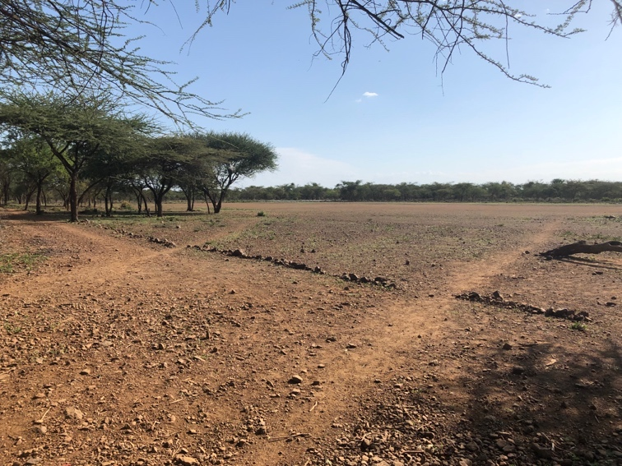

The barren landscape of East Pokot even during “rainy” season. This is the most green that it gets according to locals.

Day 1:
Winnie and I had arranged to meet in Nairobi. She flew from Eldoret where she lives to come shop for supplies and travel from Nairobi with me by car to Orus so we could strategize beforehand. We met in the morning at a coffee shop to discuss our supply list. Originally, GFH had earmarked $100 to buy birth kits (aka “mama kits” in Africa) to bring with us. After some discussion, we realized that bringing any supplies and handing them out would be a grave mistake. She had been very clear with the community that there would be NO handouts. This was a trip for training and permission from “the men” and the chief had been given. The chief was a woman, appointed by the government and this did NOT go over well with the men of the community. She had been beaten (almost to death) a few times by villagers when they disagreed with her so the “permission” we had was tenuous at best.

We went to pharmacy and decided to buy a few rolls of gauze-like cotton to give out to the TBAs that had births coming up soon and then maybe gauge based on how that went if/what supplies could be distributed in the future. We also bought enough water for our team to survive on while there for 3 days. Her mother (one of the trainers) was going to meet us at the halfway point as she would come by car from Eldoret with our food supplies since it was less expensive than buying it in Nairobi. Winnie and I said goodbye after shopping and I went to meet a friend with plans for Winnie’s driver to pick me up at 7am before picking her up at her friend’s house so we could start the long journey.

I met my friend, someone whom I had worked with in South Sudan years before and was now living temporarily in Nairobi. She told me that East Pokot would be somewhat like Somalia, or for that matter, being on the moon: very dusty, desolate, and entirely inhospitable. She was not wrong.

Day 2:
The driver arrived at eight instead of seven with a genuine apology about Nairobi traffic. The surprising part wasn’t the lateness or the traffic, it was the apology. I mention this mostly as an example of how little it takes for me to decide what I think about a person. Ben was likeable and I trusted him right away because of the decency to apologize even though the lateness was inherent in it being Africa. The morning gridlock was peppered with people on foot weaving between cars selling small bags of peanuts, large laminated classroom maps, sticks of gum, lightbulbs and I was stuck in my usual catch-22 of whether to keep the window rolled up to avoid the pushy, sad eye routine of the various men, women, and children reaching palm-up through the window, or withstand the morning heat without fresh air. Begging is an industry and an artform, especially in Kenya, and contributing to it is condoning oppression. I remind myself of this as a woman hands four small bruised plantains my way through the passenger window. She is thin, with hallow eyes, delicate Maasai beadwork dangling from her ears, clearly from some village but now transplanted into the morning traffic near a massive shopping mall where urbanites go to buy Coldstone Creamery and iPhones. Ben somehow feels that this is the one who has found the small hole into my heart and rolls the window up using the button on his side. In Africa you always need allies. Where we were going you need someone who is willing to die for you if it comes to that. I smile silently, pleased that we had somehow already agreed to this pact, having known each other for 20 minutes and spoken only a handful of words to each other.

An hour later, we finally reach the outskirts of Nairobi. Winnie and her friend Cindy (a filmmaker who came with her to Orus last time and documented it) got in the car and we chatted a bit about logistics. Next we stopped at someone’s house to get a large box of donated shoes, and crammed that in with the rest of everyone’s gear and set out for Nakuru where we were meeting more team members and getting supplies. I was piecing together the plan as we went since nothing had really been explained. We were also going to meet Winnie’s mother, a retired midwife who would help with the training, and a translator in Nakuru.

The road was paved and unfolded across the Rift Valley where the city traffic transformed into throngs of safari vehicles parked along scenic spots overlooking the dense forest. “The migration is on in the Mara.” Ben quipped which I understood to mean that it would take more than the expected 4 hours to get to Nakuru. The Maasai Mara is why most people come to Kenya in the summer in hopes of seeing a National Geographic version of wildlife in action. The first couple of hours towards Nakuru shares road towards the Mara until a point where vacationers turn into the lush valley and we would head into the desert. Winnie pulled out her phone to text her mother about us arriving late because of the Mara while Cindy gossiped with her about someone they know who just broke up with a boyfriend. I just watched as the road unfolded through the valley. I gathered from the conversation that Ben was the driver the first two times that Winnie went to East Pokot when she did the needs assessment that led to this training I was going to conduct so I turned to him and asked why all my Kenyan friends were incredulous when I told them where I was going and then warned me to be careful. “ Pokot people are not afraid to die. They have no regard for life. The military and police have resigned from working there; it is lawless.” He kept his eyes on the road but I could feel him trying to gauge my demeaner.

Here is the entirety of what I knew about this trip at that point: The village we were going to is called Orus. It is in Baringo County, in the East Pokot region of Western Kenya, which borders Sudan. The people are pastoralists which means their survival relies upon owning cattle and keeping them alive despite the cyclical drought of dry season. They don’t grow things. They don’t have access to healthcare. They are incredibly aggressive. Many people die of snake bites, bleeding to death after giving birth, or being shot or beaten during cattle raids. I read in Winnie’s briefing based on her first two visits to Orus that the closest real hospital is more than 200 kilometers down a dirt road and nobody owns a vehicle. There is a small dispensary, a 3 roomed building with a community health worker and a nurse, a few basic medicines and supplies, about 40 kilometers away. A school was built but it is not used, but there is a single solar panel in the schoolhouse which may or may not work for charging phones. The girls are circumcised around age 9-10. It is done with a sharp rock or hammered piece of found metal. They remove all the labia and the clitoris, tie her legs shut and leave her in a cow shed to heal by herself for 2 months. If she doesn’t die from infection, she will be married off. If she dies, her body is thrown to the hyenas. These are things that were stated matter-of-factly in the briefing alongside a description of how far they walk every day to a borehole to get water, anecdotes about how women are routinely beaten for offenses like letting a baby cry, not making a man’s tea before he even anticipates wanting some, or for attempting any type of family planning.

I was formulating in my mind how the training would work. I’d been warned not to call it “training” as this implies I would be attempting to educate or empower women. Mentioning family planning would turn the situation violent so that was definitely out. Our goal was to discourage the TBAs from delivering babies in Orus but instead facilitate a community solution to getting women to the hospital (at least the dispensary) to deliver. I needed to do with this without using the word “preparing” because the Pokots have a taboo against preparing for births. Since so many women and babies die, it is considered bad luck to even talk about it. Our goal was to teach very basic emergency obstetrics and how to get a baby born not breathing to breathe in case they don’t make it to one of these medical facility sites in time. Which they won’t. We knew this. At that point, I began to realize the whole thing was already somewhat absurd. I will say here that Winnie is a true champion and everything you could want in terms of a person committed to helping the underserved women of Africa. She is smart, committed, hard-working, a good listener, patient, and very fun to be around. But she chose a very challenging mission and I felt it was my job to support her in this in any way I could now that I was there.

We arrived in Nakuru and Winnie hopped out to greet a group of people in the taxi van next to our car. I was confused as I counted the number of people and wondered who the extra ones were and if we were taking more than one vehicle. I quickly realized the idea was that we would all pile into the single Land Cruiser along with everyone’s bags. I stood in the dusty parking lot with a small herd of goats while I watched the logistics of vehicle packing unfold. It felt like I was in the deep gut of a furnace and we were still hours from the desert. After a few moments a tall, thin, very dark young woman came up and hugged me. “My name is Noella and I’m the translator. I looked at everyone’s ass and yours is the second smallest only to mine so we will have to sit together in the front if you don’t mind.” I smiled agreeably, at once feeling ridiculously American for having taken the ‘small ass’ comment as a compliment rather than just for the African fact that it was. I climbed sheepishly into the front seat dwelling on this cultural divide and how much brain energy I waste on such nonsense, embarrassed at the irony of just how deeply such issues have permeated into my psyche to appear even in that particular moment.

I’ve found myself in countless African clown car situations like the one I was currently in, with alternately numb legs, staring at terrain, multitasking in my brain about logistics and why the world is the way it is and having Noella on my lap this trip was actually a stroke of luck. This time I had the luxury of a lap mate who spoke English so I got a chance to come out of my head a bit. It turned out that through serendipity or fate, Noella was educated because of a random encounter with a Catholic missionary when she was younger. She spoke English and Swahili but was Pokot and from a village just a few hours from Orus. She told me about Pokot life and ideas and how she felt compelled to empower girls and women and bring healthcare and education to her people. She mentioned that she was 24 years old, unmarried and had 14 siblings. She kept chatting as we turned off the paved road and onto the beginning of the dirt which would take us several hours to the village of Orus. As we bumped along the treacherous road Noella occasional fell off my lap sideways and onto Ben’s side of the car. She laughed infectiously and made loud pastoralist-themed jokes to him like, “Sorry! My property keeps crossing the border!” in reference to her ass being much like a cow gone astray. When I knew Noella for about four hours, I turned and looked squarely into her gleaming eyes and said sadly, “You are going to be killed one day for what you are doing, aren’t you?” Her mouth gently stretched across her face into a mournful smile as she exhaled a quiet chuckle, “Yes. I am sure of it.”

After hours (and hours. And hours. And hours) we arrived just before dusk. There was a small building that I learned the backstory of. The Kenyan government had built it as a health center. It has 4 rooms. No running water, no electricity. The problem was that without consulting the community, they used government logic and built it in the most central part of the village thinking it would then be accessible to everyone. However, the Pokot people have a strong belief that it is bad luck to be anywhere near a dying/dead person or in a place where someone has died. Having a health center used in the center means that when someone died there, they would all have to then indefinitely avoid being near that part of the village. Forever. Yet the borehole they get water from is nearby, so they never used the building, which was fine because there are no health workers to staff it anyway. They call this building the “lodging” for when visitors like ourselves come to the village. Don’t be fooled; we were the only visitors to have come, nonetheless, this is how it was explained to me. A few village women including Helen, the community leader came to meet us and get us settled in. We pitched tents in the surrounding forest and laid some blankets on the concrete floor for others to sleep on. I told Noella I wanted to wake up at sunrise and walk to the borehole to see how the life of a Pokot women starts in the morning. We went to sleep to sounds of screaming in the distance. Brutal, loud, female screaming from several different directions.

Day 3
Noella and I woke early and started to walk. Ben saw us and asked if we wanted a ride but I was insistent we walk and Noella, being Pokot, didn’t care either way. She walked every day of her life to get water. We started along the dusty path through pricker bushes and I noticed the terrain. It was not particularly pretty at all but this apparently was what everyone described as the “lush” season. It could not have been more opposite than the dreamy world of Central Uganda I had just come from. We arrived at the borehole to find a mother and her young daughter, around 7 years old. Her eyes were averted; Noella said she had never met strangers before and was taught to be wary and afraid of them.
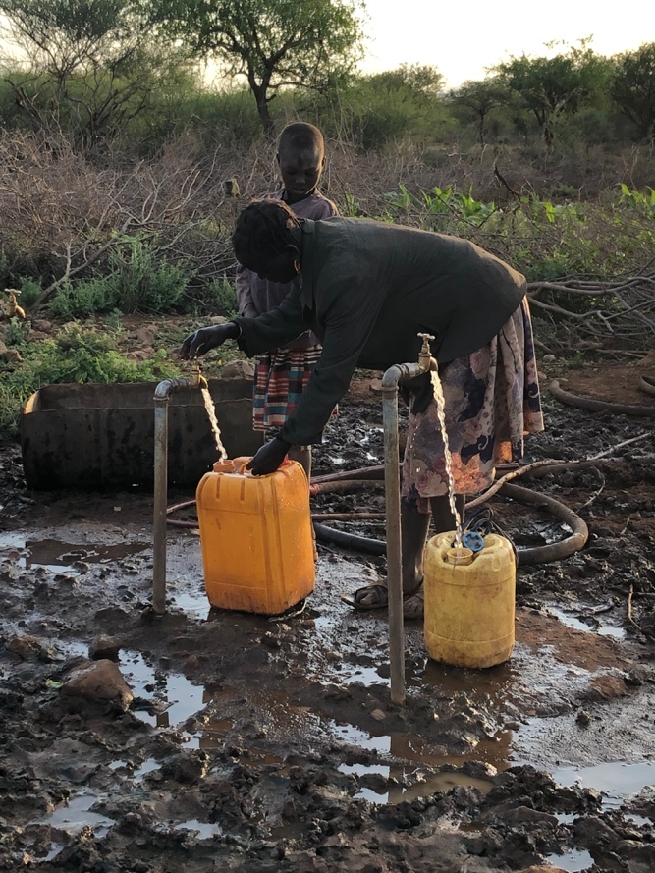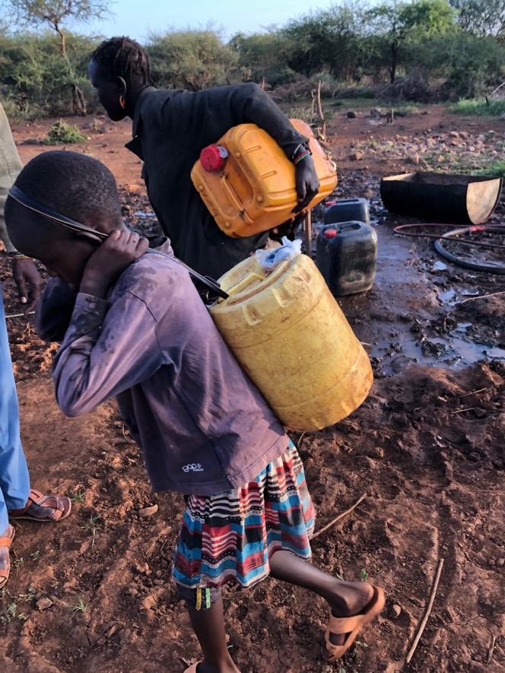

Morning water at the borehole

We found out that last night’s screaming was likely women getting beaten by their husbands or maybe some type of retribution from a recent cattle raid. The village chief was not around; she had been summoned to the police headquarters and would not be back any time soon so we were there without her. Apparently a group of young men and boys had raided another local village to steal their cattle. They killed a bunch of school children and pregnant women in the process. It was in the news in Kenya and was a big deal in terms of the government and police getting involved. The village chief had run into a group of boys and men from Orus with cattle that she did not recognize and had a conflict when she confronted them about it. It turns out the cattle raid was led by the men of the village we were staying in. One thing I should say about this region is that there are more weapons than there are people. It’s one reason the government has had difficulty controlling the area; the civilians are heavily armed.

We realized we were in a time crunch. The training started early and we needed to get set up before people came. Ben appeared (sort of magically out of nowhere) at the borehole with the car and offered us a ride. He had been on his way to the manyatta (collection of huts in a settlement that each family has) to pick up Helen for the training. We offered the small fragile girl carrying water a ride as she lived in the same manyatta. She stared at the ground as her mother forced her into the car. Noella said “Look, she is shaking. She is terrified. She has never been in a car or near strangers.” She indeed was shaking. Noella asked her something and she answered in a whisper. She translated, “She says she wonders how the trees are moving.” I looked outside as we whizzed past the gnarled, thorny, and dry trees and understood what she meant.

We arrived at the manyatta to meet Helen. I met her husband and some other men. Her husband was amicable and shook my hand heartily. I noticed his ring; it was metal and formed into a sharp blade that extended from his knuckle. I found out later that he routinely (along with his other wife who participates) beats Helen, once recently almost to death for secretly getting a birth control implant after walking 40km to a health dispensary. She had it removed from her arm and at age 25 already has 6 children. The ring is worn while beating women which is why all the women have extensive scarring that is visible up and down their arms. She invited us inside for tea as is customary despite that we were all running late. Her children all were fascinated when I showed them photos of my kids. I got many compliments about how white women usually are “not very useful” but I had 4 children so I was quite impressive.

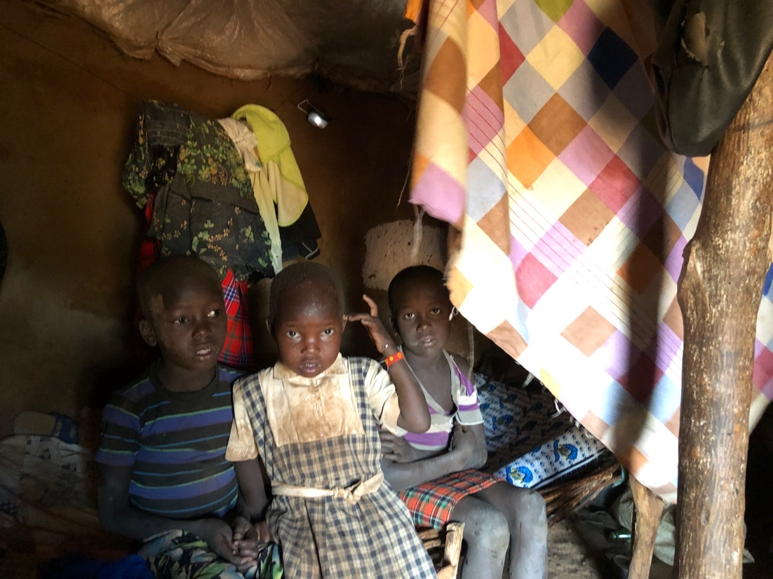
Inside Helen’s house; these are 3 of her children

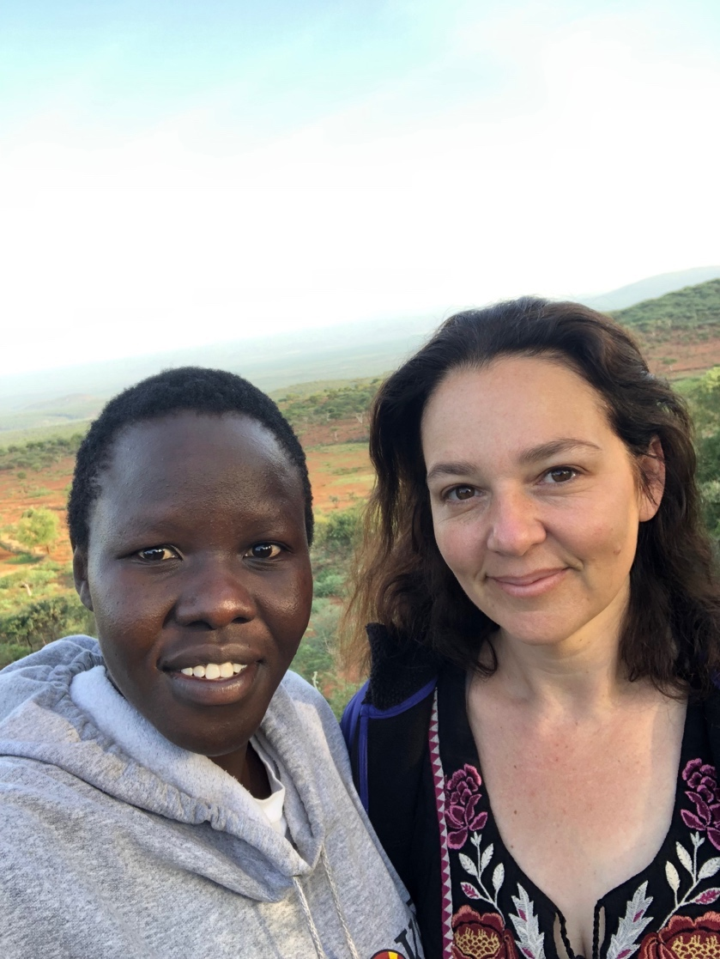
Me with Noella as we enjoyed the incredible view from Helen’s manyatta. This is a photo of one of the most courageous and wonderful women I have ever known. She is a smart, funny, determined, and tough.as.nails.

We eventually all drove to the training site. The government had built a school that is a one room building. It is unclear whether or not it is ever used. Helen sometimes is a teacher apparently and the school is taught by her with children up to around age 8. This seems like an actual impossibility to me though because there is NO WAY Helen is allowed to take the time to teach instead of maintain her extensive duties as a wife. Women are expected to fetch water, make tea, make food, care for children, build (yes, build) and maintain the mud/thatch roofed houses, sweep, clean laundry, and tend to the goats. The men do nothing. N.O.T.H.I.N.G. They sit under a tree all day waiting to be served. They steal cows and sit watching cows. That is all. I was starting to think the best health intervention that could happen would be recreating the island Wonder Woman was from whereby all the men were sent away for like 5 years and the women ran everything. I bet the men would come back to Pokot and it would be as efficient and beautiful as Singapore. Likewise, I cannot imagine that children (girls) would ever be allowed a break from manual labor to sit in a classroom. Nonetheless, the government had built a building so that is where the training took place.

Winnie had arranged for 30 TBAs to come and get trained. As she suspected would happen, about 60 showed up. Some had walked from absurdly far away. We realized then that they had not really accepted the message, despite having been delivered many times, that nothing was being given to them other than training.

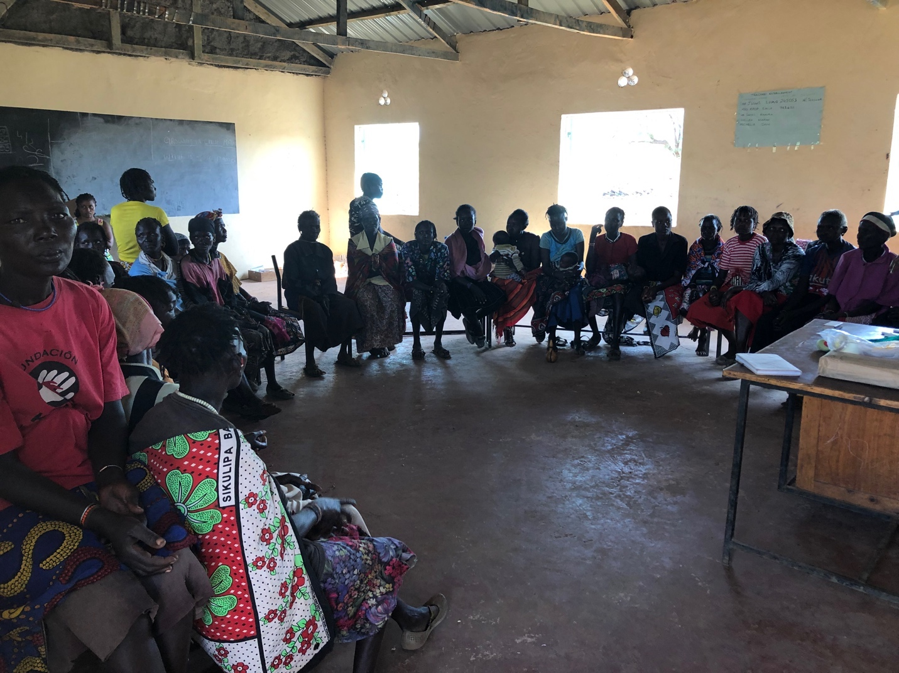

We began the training by Noella explaining why we were there. We agreed to let everyone stay but asked what they hoped to learn. As they spoke, Noella translated and Janet wrote on the chalkboard the list of items they were interested in learning about. I found it all comical because nobody there was literate. It was then that it occurred to me that Janet, who was sort of “famous” in Kenya for being the head trainer for the Helping Babies Breathe program (HBB) (low resource infant resuscitation) had never worked outside of low resource facility-based places with trained health workers who at least were able to read. She spoke very fast but Noella kept up. The women looked bewildered at what was going on. The list generated showed that they had many questions, but more so it reflected that they had seen some very bad complications and that moms and babies die routinely. When I asked what happens when someone dies, I was told they do not want to be near someone dying or dead so they drag them to the forest and leave them there. Someone peeks occasionally to see when/if they are dead but essentially they don’t bury them; they let hyenas just eat them. If, for example, a woman dies of hemorrhage, they believe it was because she must have cheated on her husband so she deserved it. If a newborn is dying, they leave it for hyenas as well. I started to wonder what good it would do to teach HBB. Janet interspersed her staccato speech with prayers and blessings in the name of Jesus (I found out later she is also a pastor) and I could see the local women looking impatient, annoyed, confused (?) I could not understand what it was.

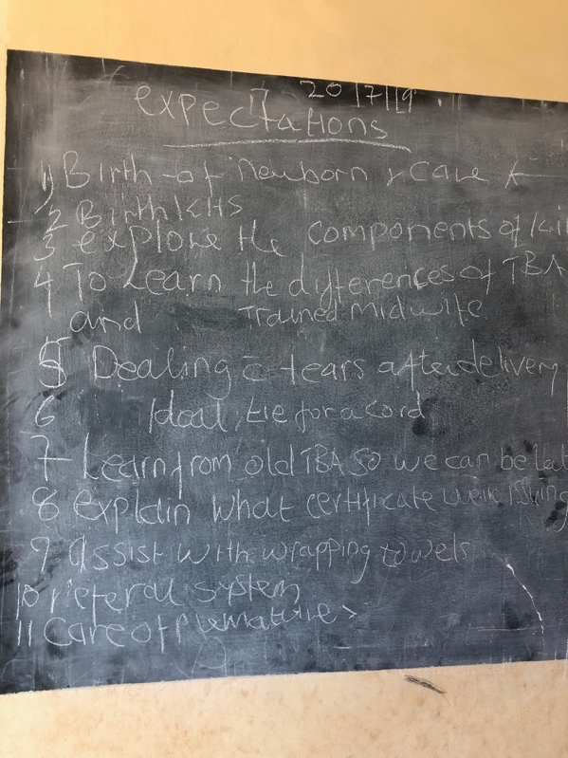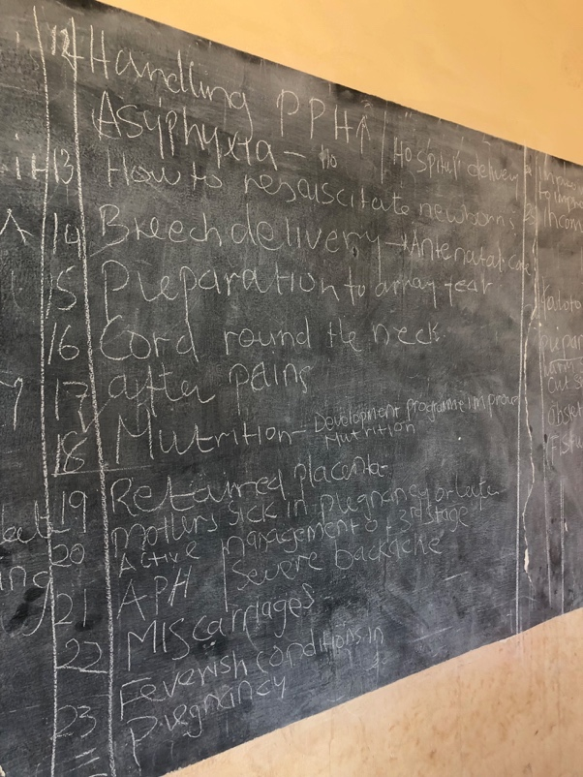
Goals and expectations written on the board

We decided to start the training with having them show us how they deliver babies so we could understand their methods and then show them what happens in a facility-based birth. The goals was to gain trust and explain the rationale for what happens so they are not afraid or confused and choose to come to a health center to deliver.

What we learned is that the women give birth outside because if they die inside, the villagers would have to tear the entire house down and the owner would need to rebuild a new one. What usually happens is that a woman in labor would still need to take care of her basic responsibilities (water fetching, cooking, goats, children etc…) and then as she got close to birth she would walk to a TBAs manyatta. This is anywhere from 5-10km away. She would need to bring any water or food with her for herself because the TBA cannot/will not provide that to her. Once there she hangs out alone under a tree laboring until she is ready to deliver. Then she goes to a specified rock behind the TBAs house and leans against it to deliver. If it is her first baby, she will need to be cut open with a small, sharp, knife-like blade called a teremu that the TBA heats over a fire to clean. That is because she will have immense scarring from the circumcision process she previously underwent. Once the baby is born, the cord is tied with a piece of bark and the placenta is thrown in the forest. The woman shoves cow manure and soil into her vagina (to stop the bleeding as they do not have underwear or pads or cloth etc…). She then wraps up her baby and walks home, typically fetching water on the way as she will need to cook and clean when she gets home.

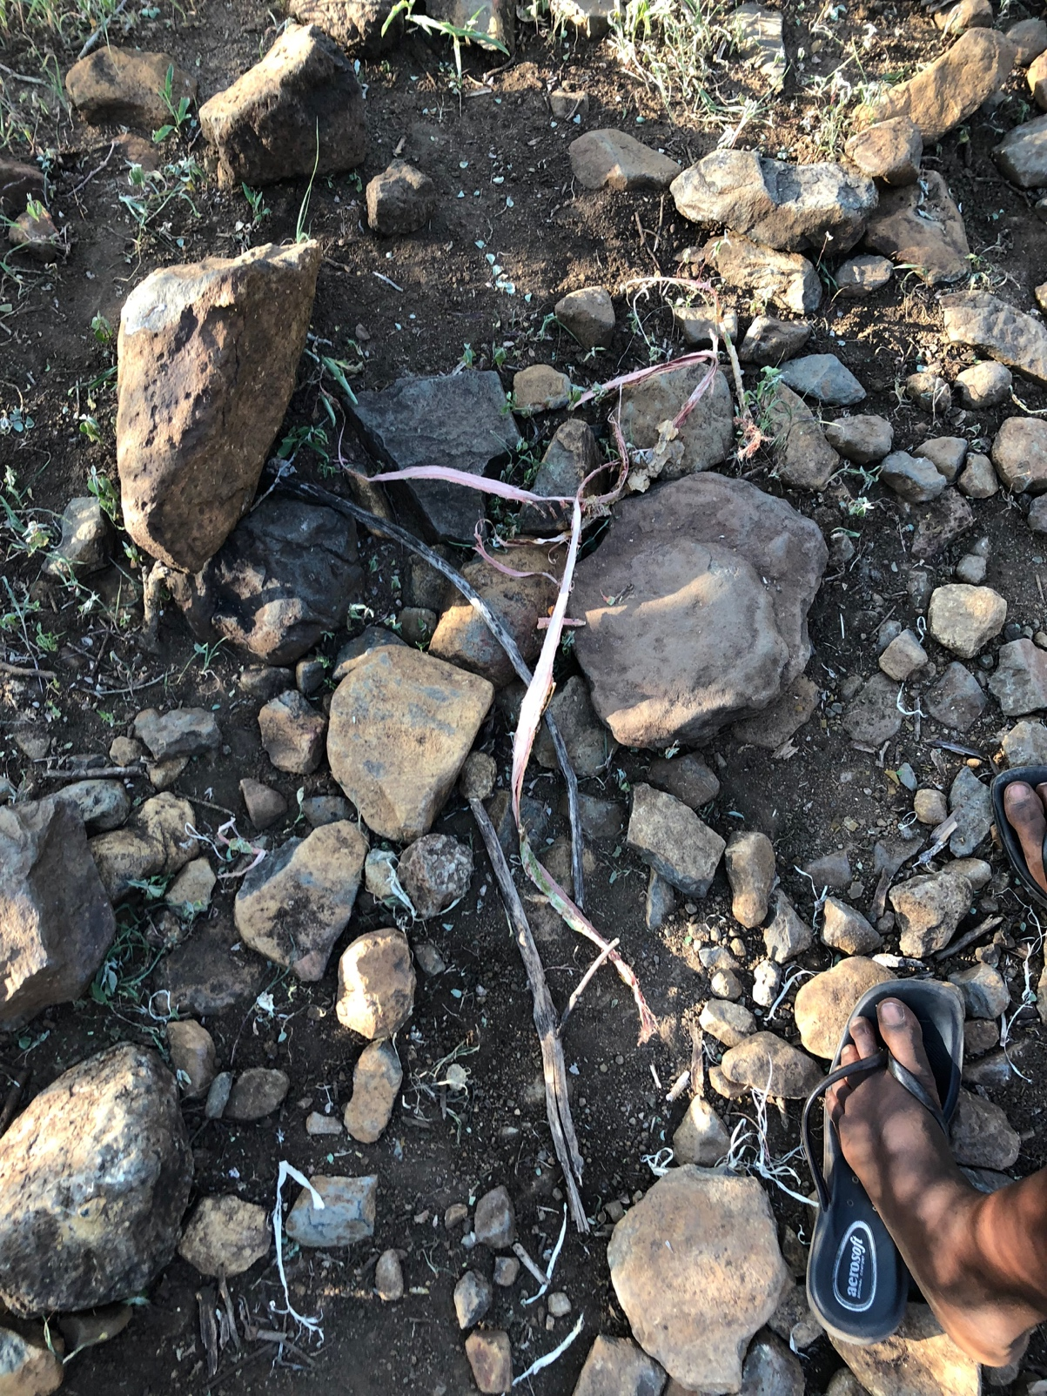
This is the type of bark used to tie an umbilical cord

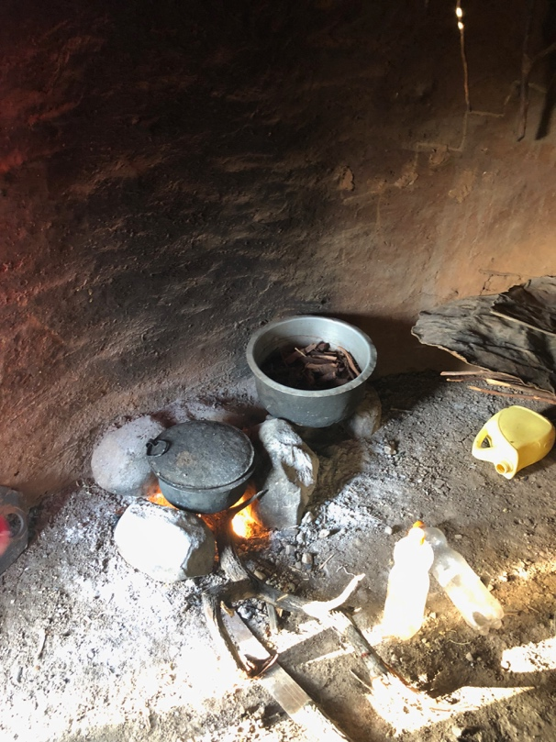
The TBA’s firepit. She has bark boiling because she also makes general medicinal items that she sells
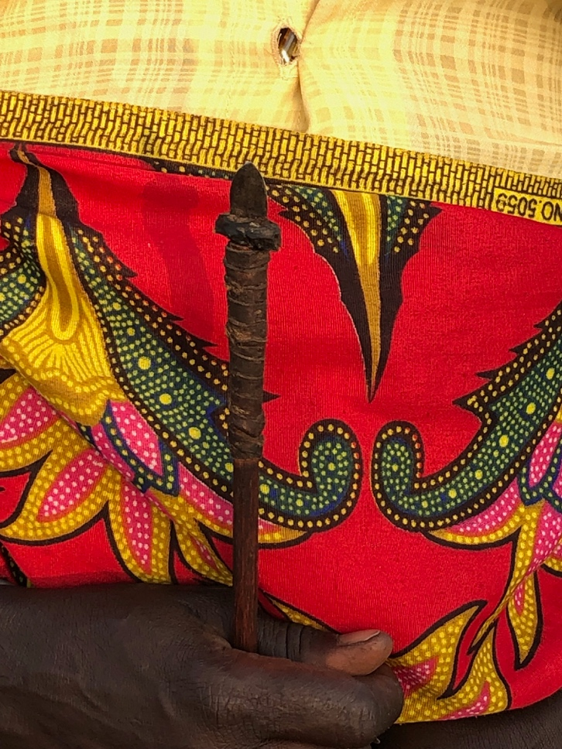
This is a teremu.

After learning all of this, we demonstrated how we deliver babies in a facility. This included showing them the components of a mama kit. They had never seen gloves so I had to show them about 5-6 times how you put them on and take them off. We practiced saying the word “gauze” over and over as a group so they could ask for this item if they were ever to buy it in a dispensary. I walked around and showed them what a razor blade was and they looked at it wide-eyed with curiosity. In retrospect it was a good call that we did not buy Mama kits to distribute because the reuse of razors as well as the use of them for circumcision would be impossible to prevent. I kept reminding myself that the actual goals was not to help the TBAs learn how to safely deliver moms and babies. The goals was to get them to NOT deliver moms and babies unless they HAD to because the woman did not make it to a health facility. Which as I said before, she was never going to reach one. The bottom line is that only a handful of women had walked the 40 km to the closest dispensary to deliver. This dispensary had varying degrees of staff who may or may not be working the day someone shows up, and limited supplies. When lucky, they had medication to stop basic hemorrhage and to resuscitate a baby (up to the step where meds would be needed) and they *occasionally* had some type of transportation available to get to the actual hospital (some 200km down a dirt road) that had actual midwives, surgeons, and an operating theater.

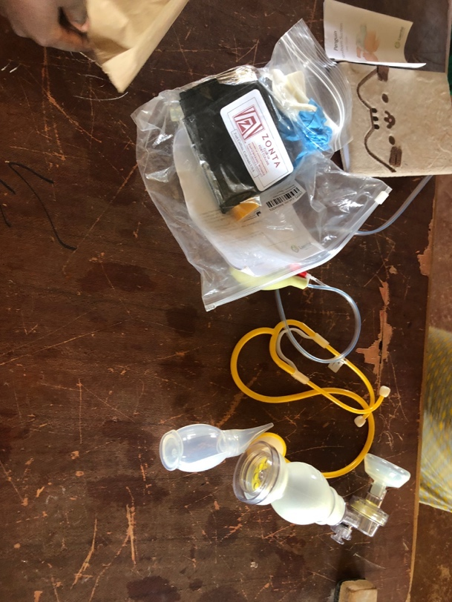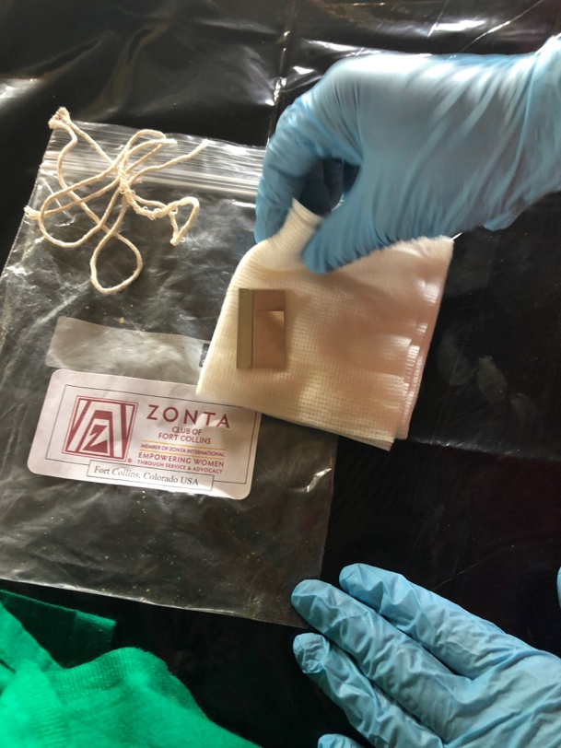
Me showing them the contents of a Mama kit and an Ambu bag for HBB

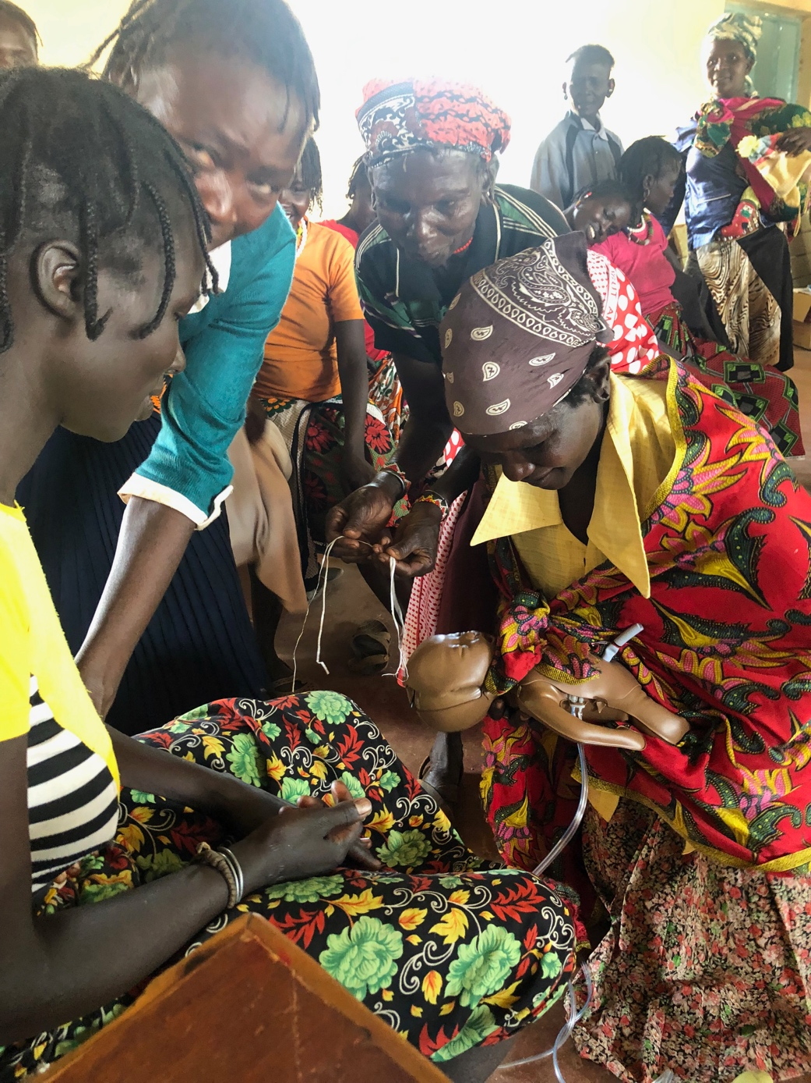
Women practicing some of the things we had just shown them about skin-skin right after delivery with the baby model

At some point during training, an old man, cataract-laden wearing the distinct metal knife ring came to the training and started screaming. Noella said he was yelling that the women had wasted enough time and they needed to take care of their children and do their real work. Apparently a child in the village had cried for his mother and so the men became aggravated as it interrupted their tree-sitting and tea drinking so they decided the women needed to come home. As it turned out the women seemed saturated anyway. Noella pointed out that most of them had never sat for even a full hour before in their entire life, never mind a half day in a classroom. They were overwhelmed and started asking when/if we were going to give them maize to bring home. We explained that nobody was getting anything. We had created certificates of completion for the 30 expected participants thinking this would be nice. I had done this with TBAs in other regions before and it was super successful as they felt proud and excited as they had never had a certificate showing they accomplished something before. In Orus it turned into massive drama. They thought it could be used as a birth certificate and thought their children (the boys) maybe could use them to register in the school several tens of kilometers away. The original 30 and the extra women started arguing over the certificates. The scene went from quiet and peaceful to intense shouting and bickering in seconds. In the meantime, Jackie, a Kenyan midwife who worked with Janet in Eldoret and came along as she usually assisted Janet in HBB trainings realized the SIM card out of her phone had been stolen. Helen confronted a boy whom was apparently notorious for stealing and that side argument with loud yelling began. Meanwhile, Janet and Jackie were trying to pull the training to a formal close by praising the lord, Noella was trying to moderate various fights, Cindy and Winnie reappeared at that time (they had been off trying to sort out our food logistics as the food we had allotted for us had been used (stolen? I dunno). It was pandemonium. In the end the certificates were handed out but given all to Helen to bury somewhere and hide from the men since they would get in trouble for having them. It was unclear whether it was because they represented education or just because they got something that was theirs and not the men’s.

Everyone eventually dispersed once they understood there was no maize and we were not cooking food to share with anyone. Noella and I walked to a TBAs house (far. Incredibly far and torturous at least 7 km from the borehole, up the side of a mountain, absolutely in NO WAY accessible or appropriate as a place to give birth in that even a motorcycle, were one available, could not evacuate a laboring woman to take her anywhere). The entire village chased a chicken for a good 10 minutes for us to buy and bring back for dinner. I handed them the money and Ben appeared (magically again) and said the car was just a couple km at the bottom of the mountain. We hiked down the perilous path with a live chicken and drove back to “the lodging”. I waited until it was dark and walked to the forest. Ben had set up a solar shower that was hanging from a tree. I stood under the full moon surrounded by pricker bushes naked and washed the day off of me. When I emerge the chicken was dead and cooked. I decide to eat a granola bar and try to sleep. We sat there that night listening to the sounds of distant and surrounding screams and wails from various manyattas. Winnie and I stared at each other without speaking and gave a knowing look to each other that the woman were being beaten for having talked to us and participating in the training. We crunched some numbers on her laptop to sorted out the receipts and bills. She turned to me and said, “ I saw you broach the subject of not bringing up Jesus or prayer to my mom. I have been arguing with her about this for months. She is insistent that it will help these people.” I told her what I told Jackie and Janet, “preaching like that will either get you killed here or completely collapse any trust you are able to build with these people.” Winnie told me that she agreed and that was what she has been arguing with her mother about all these months and was grateful an outsider brought it up. I had to frankly and uncomfortably tell her that her mother (and even more so Jackie) are not the right people for this job in the future in my opinion. We fell asleep lying crammed together on a small mat incredulously giggling saying things like “what the actual f**k was that insanity that went down today?”

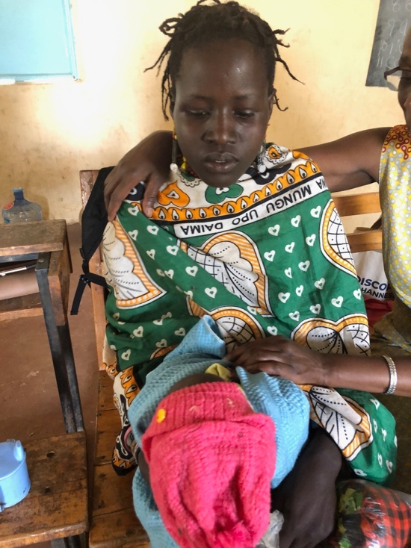
A young girl with her newborn baby. She is probably about 13. Janet has her arm around her and is admiring the baby

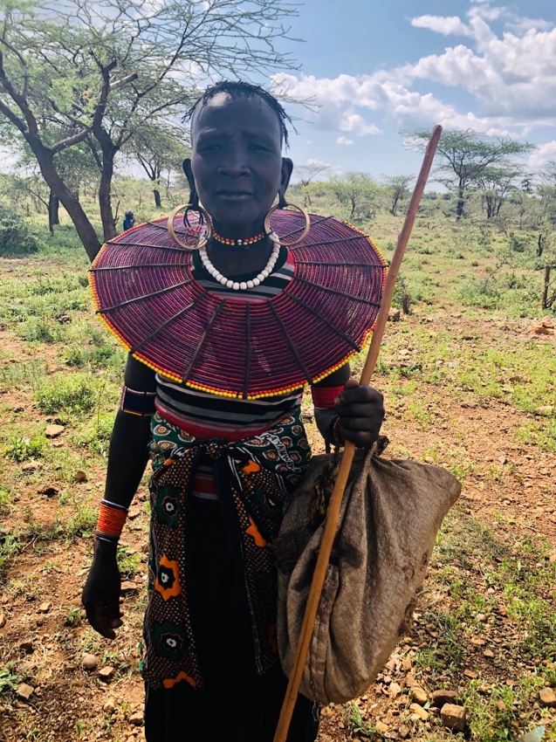
A Pokot woman who is clearly a wealthy elder. No other woman was this ornamental.
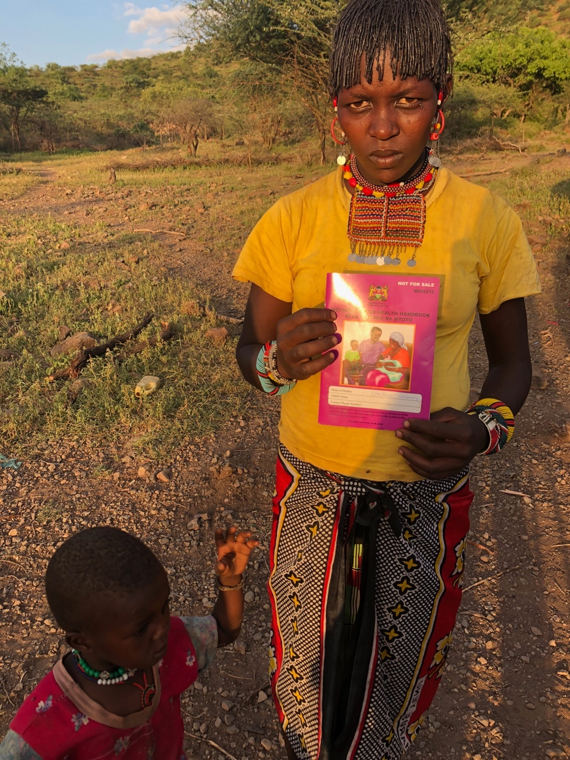
This woman is 8 months pregnant and holding up her antenatal book. She is one of the rare ones that has walked to the health dispensary to get care (2 visits) and was issued a booklet of health information (again, she can not read) and plans to deliver there.
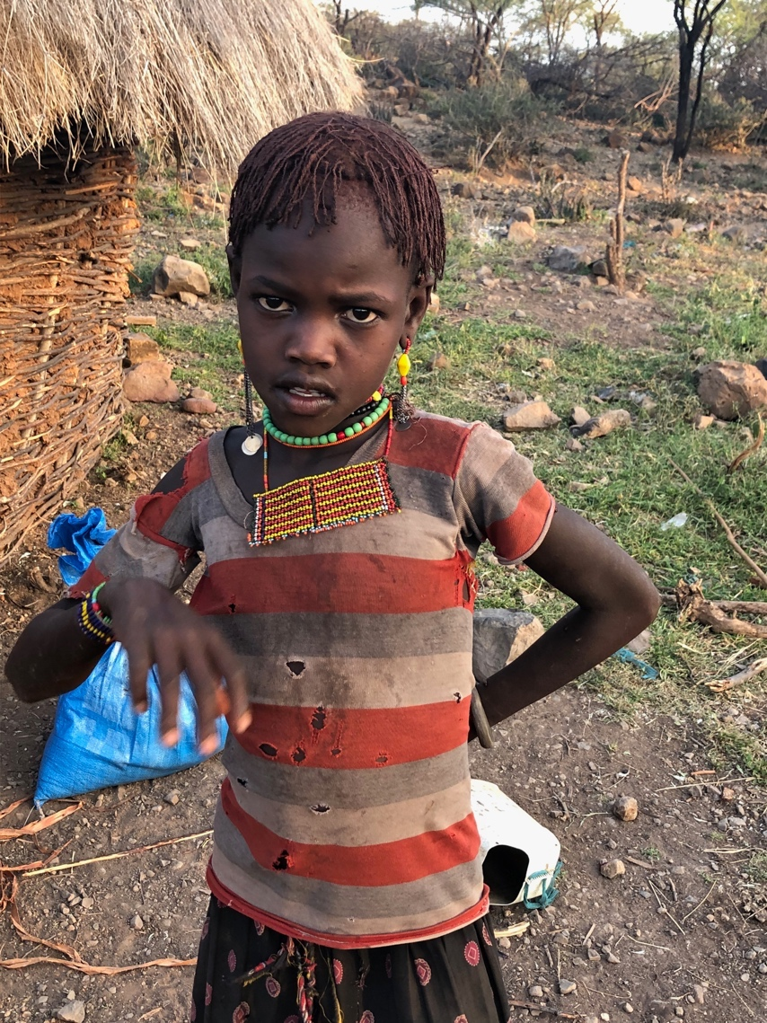
Pokot girl, about 9 years old. Her hair is dyed reddish with dirt because she is old enough to get circumcised soon.

Day 3:
We woke up at dawn and decided to leave before anyone saw us. Helen did come by and graciously saw us off as the sun came up. We bid fond goodbyes and rebuilt the precarious luggage/human ecosystem in the car with Noella on my lap and started the insane journey in reverse. I asked her along the way what her hopes and dreams were. She responded that she wanted to empower girls in her village and do family planning and educate everyone and create a community health program. She is optimistic and brilliant and it is a combination of inspiring and painful to hear her talk. She saw me admire her brass bangles and said, “ oh, these. These show that I am unmarriable. I am required to wear them to shame me because I am not circumcised and am outspoken. No Pokot man will ever marry me. If I marry a non Pokot man then my village will shun me.”

We arrived in Nakuru and everyone climbed out of the dusty car. We shuffled luggage from the car into a taxi where everyone except for me and Noella transferred to in order to drive to Eldoret. Before saying goodbye we found a small café and had tea together. None of us were ready to truly debrief and frankly were just a bit shell-shocked at the entire experience. They left and Noella and I got into the car with Ben, both of us lounging across the back seat making gleeful sounds at how incredibly comfortable we were because our limbs could be spread as far as we wanted. We drove for many hours and then it was time to drop Noella on the side of the road somewhere. She was going to catch a taxi from there to a government training program of some sort for a couple of weeks. We cried and said goodbye, vowed to stay in touch (which we do, every day!). Ben and I drove in silence the remainder of the way to Nairobi.

